Tick[√] the correct question for each answer. Sometimes both are correct.
1 √ What’s your new job like? It’s great.
__ How’s your new job?
2 _X What’s Edinburgh like? It’s a beautiful city with a castle.
__ How’s Edinburgh?
3 __ What was John like? Great. He looked much better.
_X_ How was John?
4 _X_ What was your meal like? Fantastic. The best fish I’ve ever had.
__ Do you like this meal?
5 __ What do you feel like? Not so good, actually.
_X_ How do you feel?
6 _X_ How old is he? He is 40.
___ How is he?
7 ___How is this room like? About 82 square metres.
_X__ How big is this room?
8 ___ What does Ann wear? Quite smart. She is not keen on informal
clothes.
_X__ What kind of clothes does Ann wear?
___ What does Ann look like?
9. _X__What is this laptop made of? Japan
___Where is this laptop from?
10 X What sort of pasta would you like? I’d like some cereal pasta, please.
___ Do you like cereal pasta?
___What’s this pasta like?
11. ___ What do you look like? I am a bit like my mum.
_X__Who do you take after?
___ What do you like doing?

Doplň: size, does, many, far…
- What …size…boots do you wear. 37
- How …many……….. cars have you got? 2. Mercedes and Audi
- How …far………. is your house from the school? A ten-minute walk.
- How much …does………. is weight? 1 kilo.

Very important words:

World-famous , old-fashioned, long-lasting friendship, good-looking, full –time /part-time job, drive carefully, walk slowly/quickly, explain clearly, love passionately, rain heavily, whisper softly, wait patiently, shine brightly

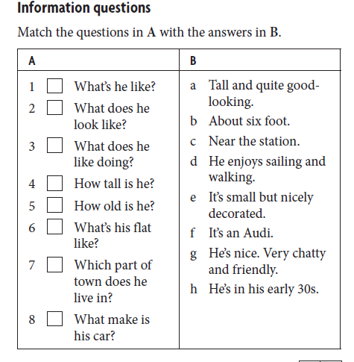
1g, 2a, 3d, 4b, 5h, 6e, 7c, 8f
Choose the correct words.

Example
I thought his latest book was quite disappointed / disappointing .

1 I do yoga every day. It makes me very relaxing / relaxed.
2 It’s been raining heavily / badly all day.
3 I enjoy cycling but I find it very tired / tiring.
4 She’s only four but she can read very well / good.
5 I never eat fast / quick food.
6 What went wrongly / wrong with the recipe?
7 You’ll need to work hardly / hard in the weeks before your exams.
8 I bought some lovely home-made / hand-made jewellery in Mexico.
9 I’m feeling exhausted/exhausting. This test was very difficult.
10. She is relaxing/relaxed because the massage was relaxing/relaxed.
11. I am charmed because I have a charming/charmed classmate.
12. My sister is interesting/interested in reading books.
13. This movie was disappointed/disappointing.

Adjectives
- My kids are ...well.......-behaved. They are always so nice.
- Your kids are ..badly.....-behaved. They are always so rude.
- He is so ..hard....... – working. He always works in his garage or in the garden.
- This decoration is ....hand........-made.
- This pizza is ...home..- made.
- First-..born........children are more responsible.

Choose the most suitable word:
- Eat a lot of fresh /brand-new /latest fruit.
- In Gelnica we have old-fashioned / ancient /traditional ruins.
- She is tall, blonde and handsome / pretty / nice.

Add –ly/- if necessary:

- I dress bad_ly__
- Try to explain it clear_ly___
- He sudden_ly__ came.
- He studies hard__-___
- Go straight_-___!
- Walk slow_ly___!
- I almost_-___ fell.
- Have you finished? Almost_-___. Give me 5 minutes.
- He drives very fast -_____.

Answer key:
Tick: 1.1, 2.1, 3.2, 4.1, 5.2, 6.1, 7.2, 8.2, 9.2, 10.1, 11.2
Doplň: Size, many, far, does
Information questions: 1g, 2a, 3d, 4b, 5h, 6e, 7c, 8f
Adjectives: well, badly, hard, hand, born
Choose the most suitable word: fresh, ancient, pretty
Add -ly if necessary: badly, clearlym suddenly, hard, straight, slowly, almost, almost, fast.

